1.ISOMORPHIC OR NOT

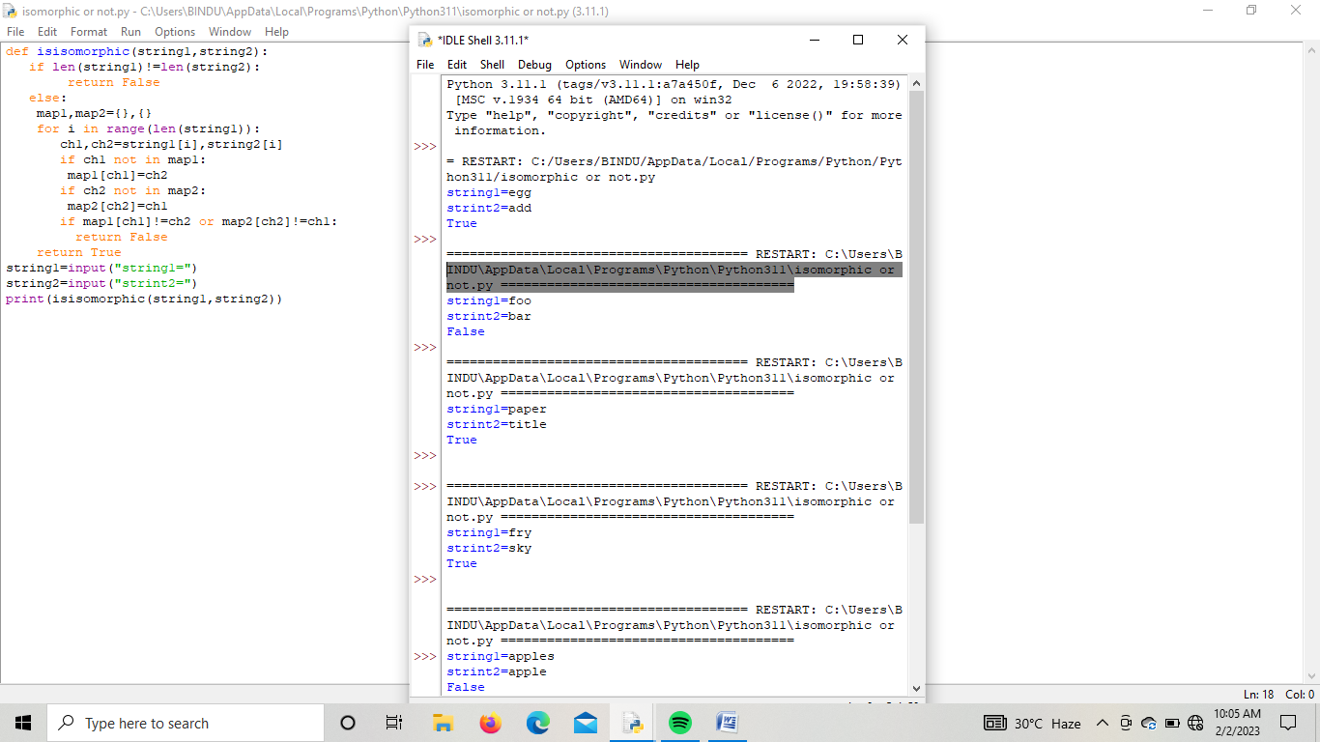

2.SUM OF SQUARES OF EVEN AND ODD

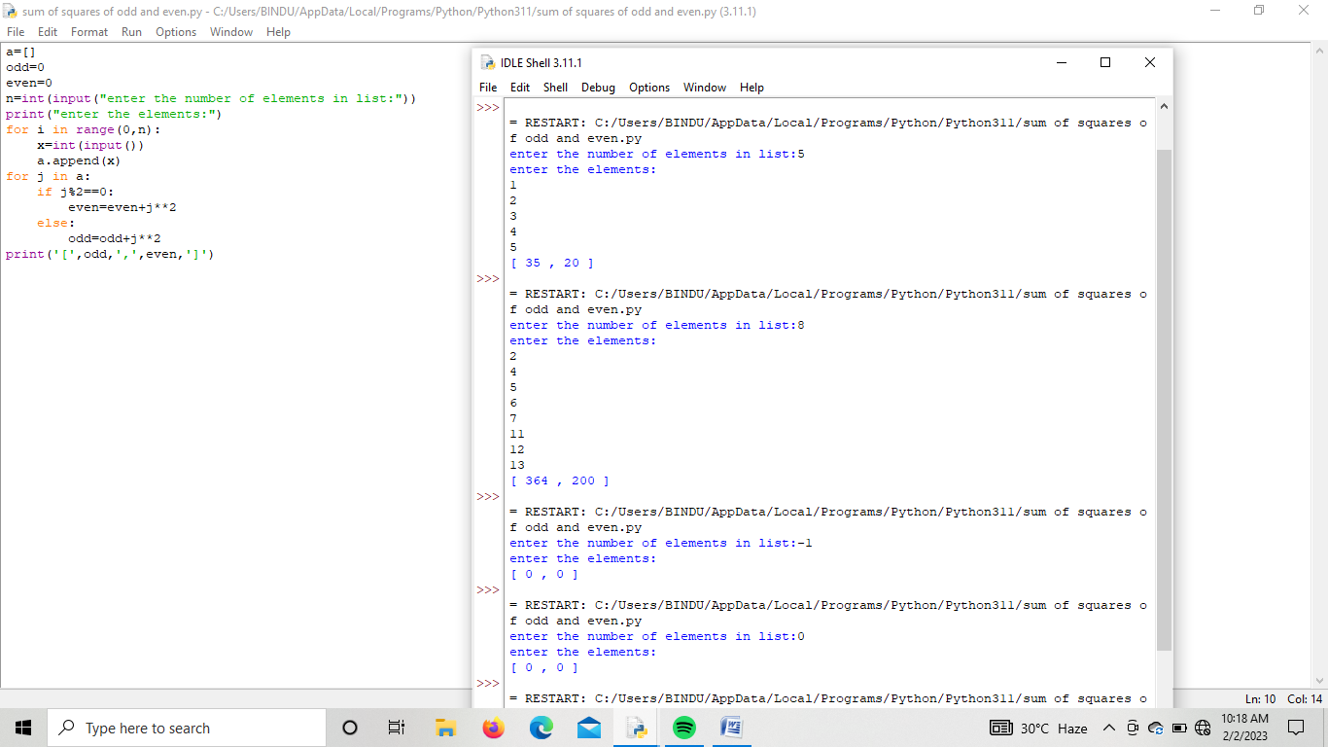

3.happy number

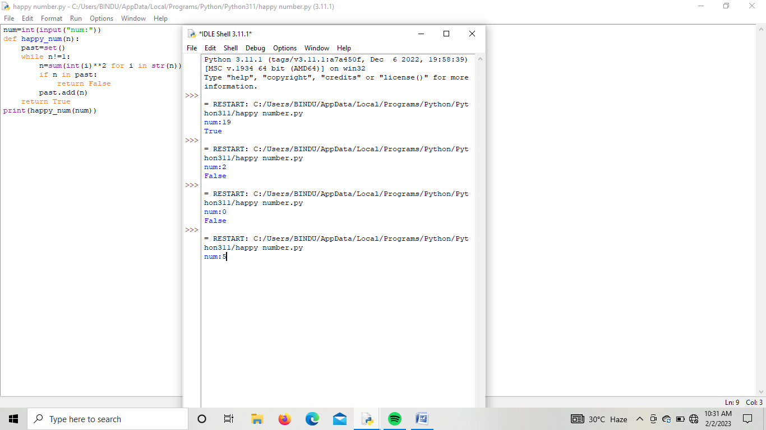

4.PALINDROME

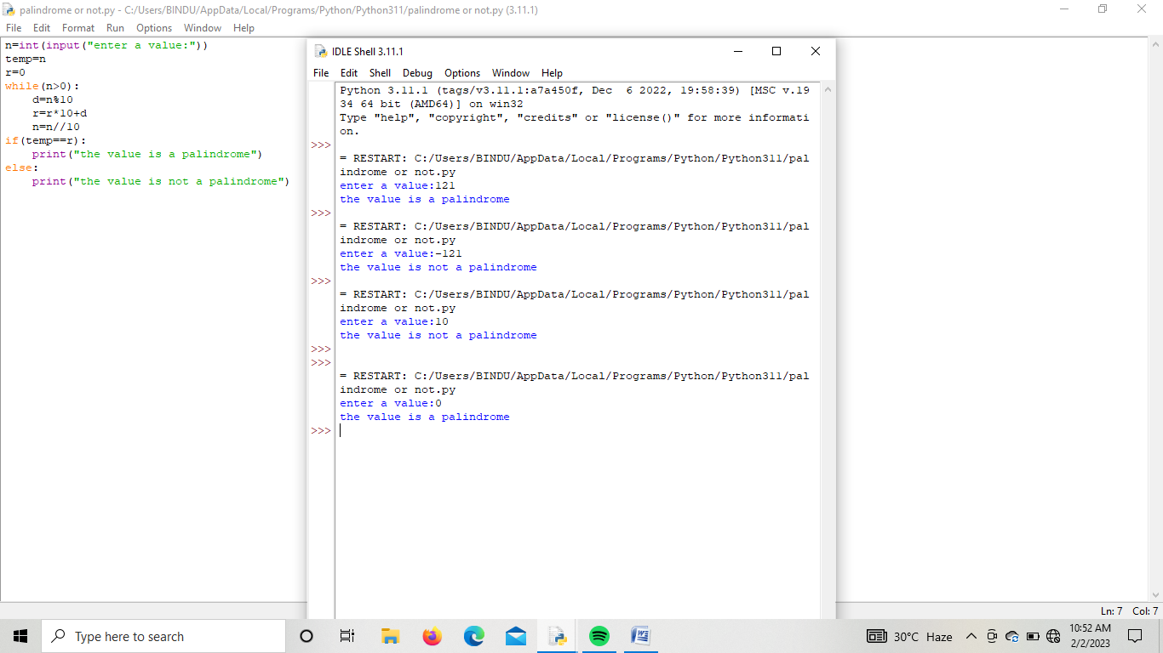

5.A BAKERY SELLS LOAVES OF BREAD

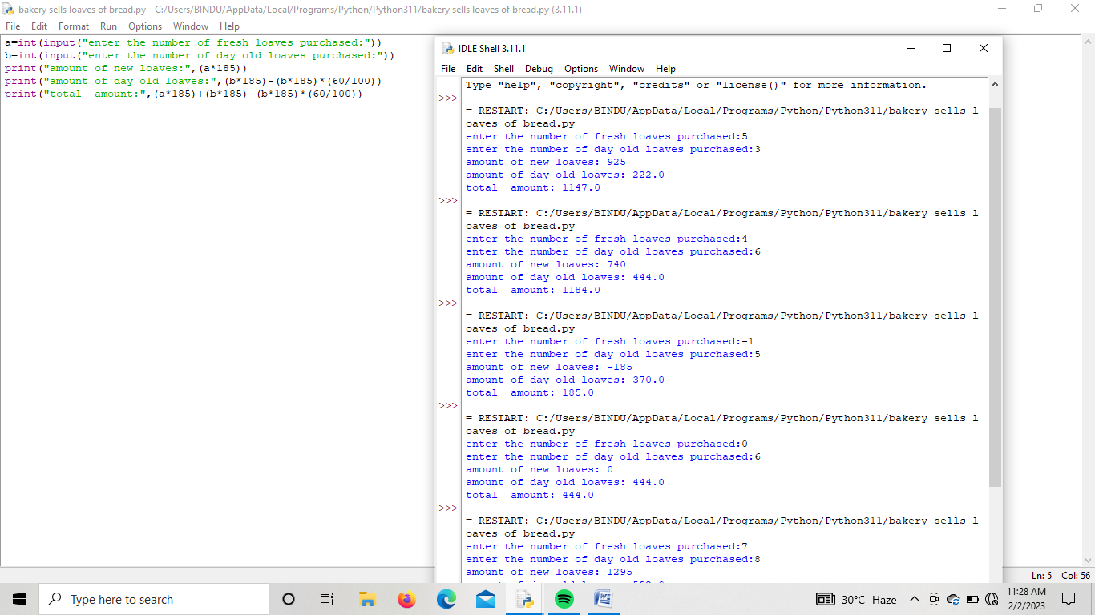

6.RETURN INTEGER CORRESPONDING TO MAXIMUM AREA OF WATER

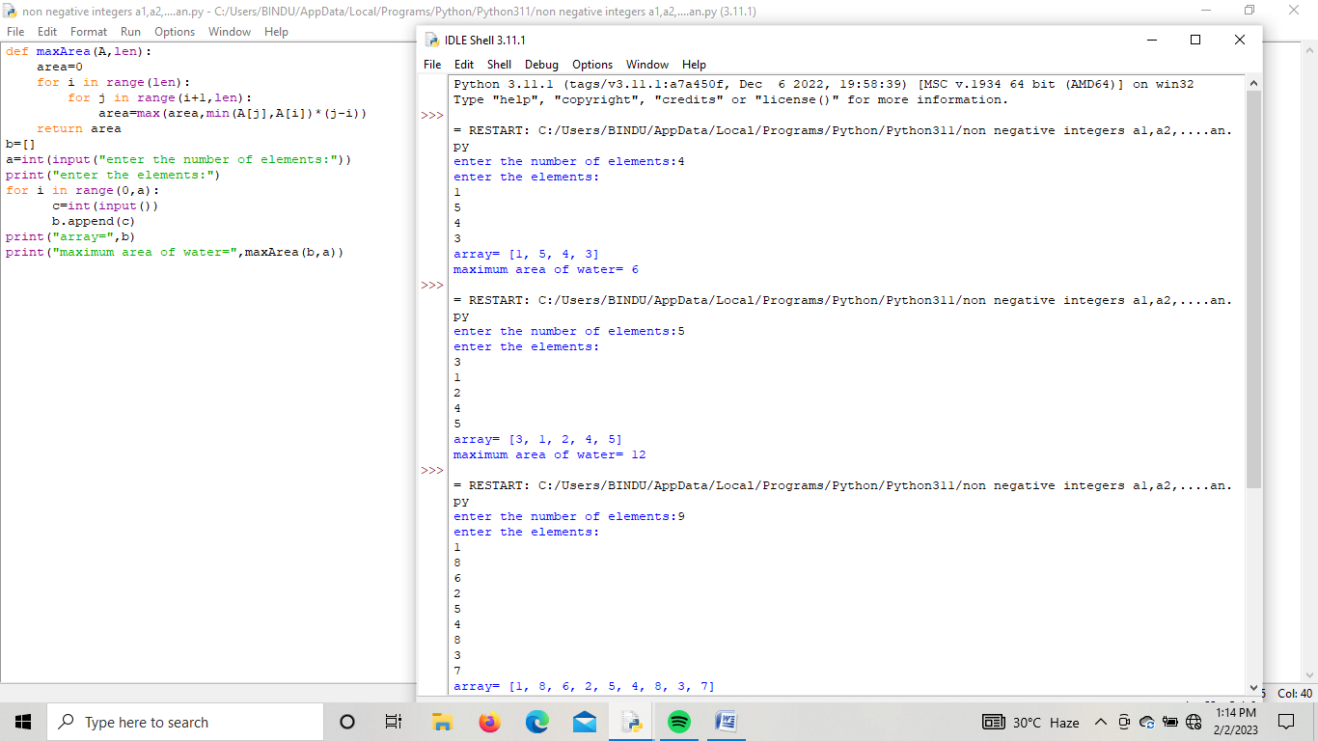

7.lexicographically soted

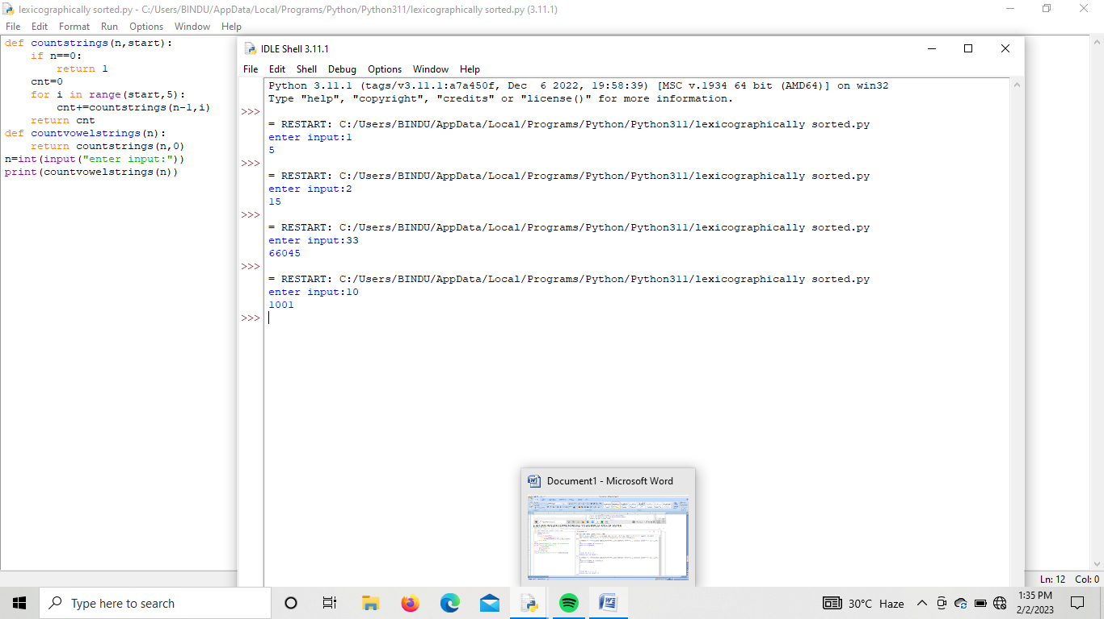

8.VALID NUMBER CAN BE SPLIT UP INTO THESE COMPONENTS

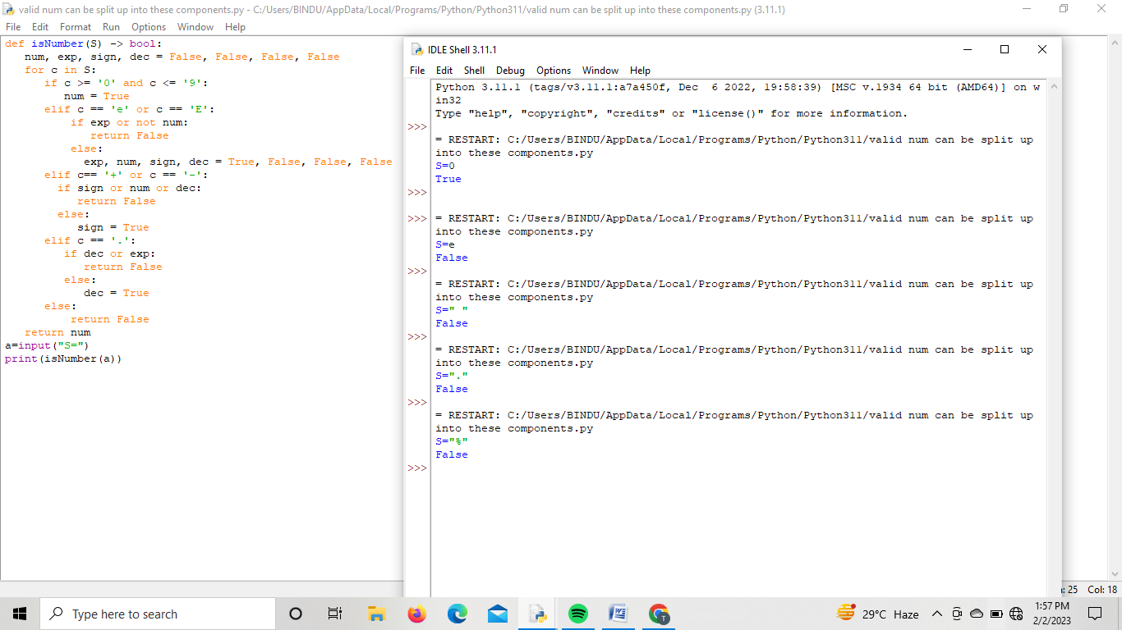

9.MAXIMUM NUMBER OF GUESTS IN CRUISE

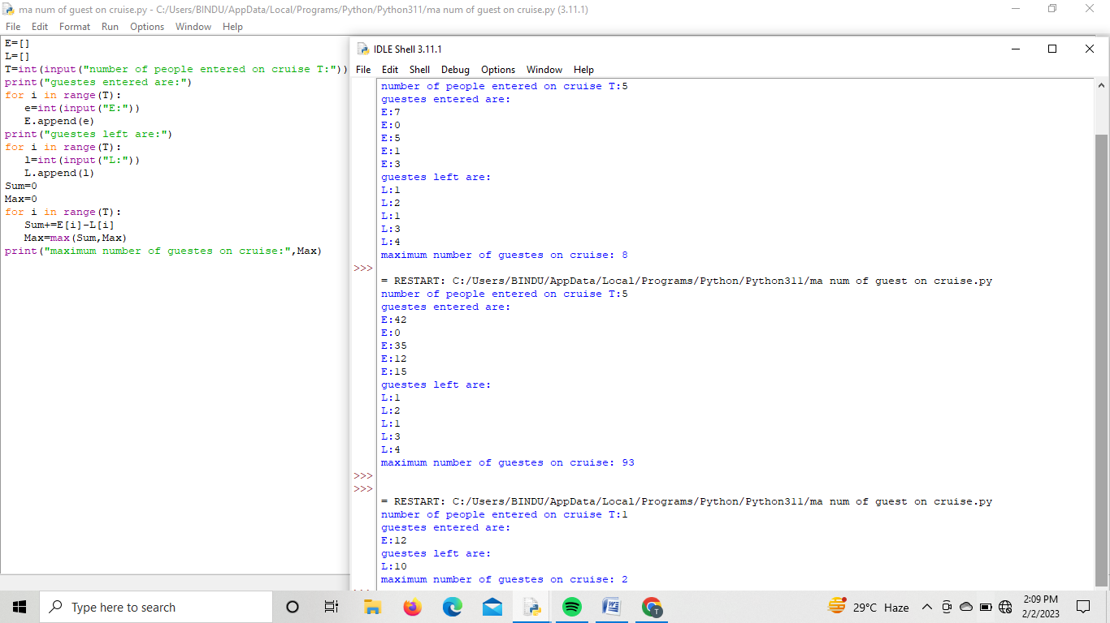

10.MODIFY STRING BY REPLACING CHARACTER BY ALPHABETS

